State Street’s Chart of the Week – Media Sentiment towards Global Epidemics

Please see below the latest ‘Chart of the Week’ from State Street Global Markets.

“Roughly one month on from the first mention of the Coronavirus, the intensity of media coverage, according to our measure of media sentiment*, is eight times greater than that for the SARS (2003), Ebola (2014) and ZIKA (2016) viruses following their respective outbreaks. Perhaps reflecting the severity of the virus or stronger measures being taken by the Chinese government to contain it. Either way, one would hope that the increased measures, media coverage, and, in turn, awareness of this epidemic will contribute to a faster reversal.”

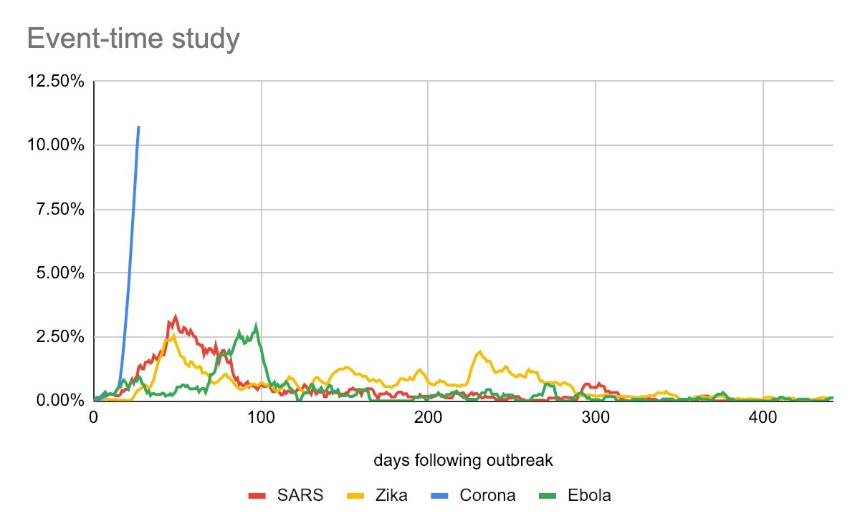

Figure 1. The media coverage diffusion of global epidemics

Metodology
To make sure that results are not driven by the number of outlets we normalized intensity by dividing the number of epidemic related articles by the total number of all articles (epidemic and non-epidemic related) collected on any given day. So even if SARS (2003-4) coverage contributed less articles in absolute terms, the denominator used to normalize is also smaller, because for that period we only used one source (NYT archive). In later periods, we utilize our general reservoir which includes more outlets and therefore has a larger denominator.

For example, say that on a given day in 2003 we collected 100 articles (the only source we used for the early periods) and found that 7 of them are related to SARS. We would then report SARS media intensity of 7% (=7/100). Fast forward to the Zika outbreak, say we also found 7 Zika-related articles on a given day but the daily pool of articles that day was 700 (a result of more sources participating in the panel), we would then report 1% intensity (=7/700). Therefore, although the number of Zika-articles is equal to the number of SARS articles in this made up example the denominator (normalization factor) drives the reported intensity to be very different.

Other assumptions include that for each epidemic, date t=1 signifies the first date for which there is a mention of the epidemic in the media reservoir (3/13/2003, 7/26/2014, 12/24/2015 and 1/6/2020 for SARS, Ebola, Zika, and Corona respectively).

* About State Street MediaStats
State Street MediaStats scours more than 100,000 media sources as well as other “Big Data” sources to estimate future price changes and risks pertaining to individual equities, country equity indexes, and foreign exchange rates. Media derived insights are aggregated to understand broader industry and macroeconomic trends that help you leverage accurate, valuable and predictive insights for your investments..

Investing involves risk including the risk of loss of principal.
The information provided does not constitute investment advice and it should not be relied on as such. It should not be considered a solicitation to buy or an offer to sell a security. It does not take into account any investor's particular investment objectives, strategies, tax status or investment horizon. You should consult your tax and financial advisor. All material has been obtained from sources believed to be reliable. There is no representation or warranty as to the accuracy of the information and State Street shall have no liability for decisions based on such information.
The views expressed in this material are the views of State Street through the period ended August 28, 2019 and are subject to change based on market and other conditions.
This news announcement contains forward-looking statements as defined by United States securities laws, including statements about the financial outlook and business environment. Those statements are based on current expectations and involve a number of risks and uncertainties, including those set forth in State Street's 2015 annual report and subsequent SEC filings. State Street encourages investors to read the corporation's annual report, particularly the section on factors that may affect financial results, and its subsequent SEC filings for additional information with respect to any forward-looking statements and prior to making any investment decision. The forward-looking statements contained in this press release speak only as of the date hereof, August 28, 2019 and the company will not undertake efforts to revise those forward-looking statements to reflect events after this date.
State Street Corporation One Lincoln Street, Boston, MA 02111-2900.
The whole or any part of this work may not be reproduced, copied or transmitted or any of its contents disclosed to third parties without State Street’s express written consent.
© 2020 State Street Corporation - All Rights Reserved

